MIS 710Class Exercise Homework: Strategy-Structure-Process Name: Kaushik M Rao
Company Name: Solar City
(1) Develop a generic customer value proposition appropriate to this company strategy.
Ans: Our primary objective is to add value to our clients' lives and make their lives easier. This allows us to expand our company and increase our profits. Money gained from the profits is used for improving the product like solar cells and design. Employees are given importance for their contribution for their work. They are rewarded with hikes, stocks and promotion. It is necessary to maintain healthy work environment so that employees can work in peace and harmony. This makes employees to work hard and achieve targets.

2)List the processes that your firm should concentrate on to excel at its chosen strategy?
Ans: Our Research and Development department is one of the largest in the company. There is separate R&D departments which conducts experiments and research in improving the solar cells quality, improving the performance. The main goal also should be to cut down the costs for materials and manufacturing.

Tech support: We should provide 24*7 tech support to customers like if there are facing technical issue with solar cells, maintenance, and installation. Ultimately this Leeds to improve in companies’ trust.
Best Quality Raw Materials: The raw materials that is used for building solar cells should be supreme quality. The raw materials that are used should be a cost efficient, should not be too expensive. The quality of the materials should not be compromised. If it is compromised
This will benefits the competitors.

(3) Does the organizational structure and process governance structure that you described in the second exercise hinder or support reengineering the processes you list under (2)? (Brief answer – but more than just “yes” or “no”)
Ans: Yes, it stymies the reengineering effort. The main reason for this is that departmental communications aren't up to par, resulting in inconsistencies. If all departments are unaware of each other's resources. It becomes immensely hard to work and produce efficient result.

MIS 710 - Process Innovation and Management In-class Exercise: Organization of your firm
Name: Kaushik M Rao
Division: Solar City

The company's workforce is divided into four levels. All employees in the company are included in these tiers.
MANAGING DIRECTOR- The CEO oversees the company (Chief executing officer) of the business The company's CEO is in charge of all final executions.
MANAGEMENT- The management team is made up of all of the company's personnel. Marketing, IT, Finance, Public Relations, and other departments are examples. The management team is led by the vice president and the board of directors

GOUND STAFF- The ground staff is made up of people who oversee the ground operations. Shipping the solar cells and installing solar cells to the clients also providing support to the clients like repairs and maintenance.
HELPERS- These are the individuals who help in cleaning and maintaining the office facilities and inventory.

Sketch an Organization Chart showing your own organizational unit a box and, as far as you can, sketch the subordinate and superior organizational units?
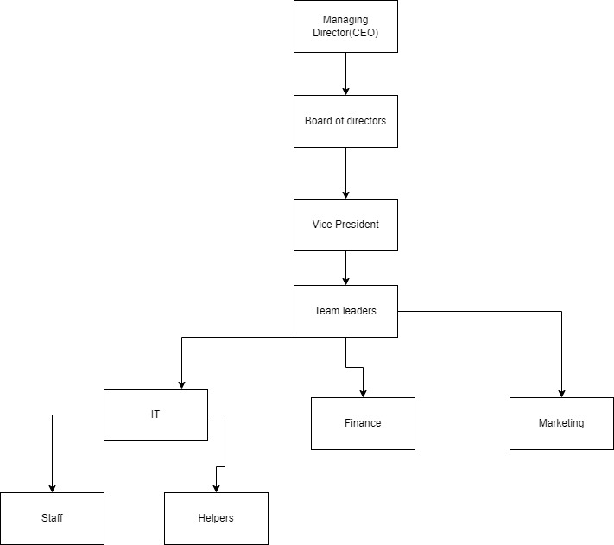

c. Has your firm developed a governance structure for major (core) lateral processes?
Answer: The employees that are selected for hiring are very selective. They go through rigorous screening process includes resume screening, telephone round interviews, live interview, they are also given a project which are expected to be delivered. The overall process takes around 5 months. In order to complete. After getting hired employees are trained in the various technologies and expect to meet strict deadlines. They are expected to attend meetings regularly. They should come to the office onetime. Late arrivals results in penalty.

Company/Division: Tesla/Solar City
- What kind of strategy does your company follow? (Operational Excellence, Customer, Intimacy, Product Excellence) and/or Resource-based? Does it have a mixture of strategies?
Ans: The company that I would choose to describe the mixture strategies of the produce Excellence and Operational Excellence.

- Briefly describe your firm’s strategy
Ans: SolarCity Corporation, based in Fremont, California, was a publicly traded corporation that sold and installed solar energy generation systems, as well as other associated products and services, to residential, commercial, and industrial customers. Peter and Lyndon Rive, cousins of Tesla, Inc. CEO Elon Musk, launched the company on July 4, 2006. Tesla Bought this company for 2.4 billion dollars in 2016. This company name was renamed solar winds
After the acquisition of the company space X started using solar wind technology for satellites and spacecraft. They did re-engineering which increased the company’s sales and profits.

What kind of strategy does your company follow? (Operational Excellence, Customer, Intimacy, Product Excellence) and/or Resource-based? Does it have a mixture of strategies?
Ans: The company I choose to describe follows the mixture strategies of Operational Excellence and Product Excellence.
Product Excellence: Basically, Solar city was a good company they have innovated ideas of Generating electricity by placing solar panels on top of the roofs or buildings. They had good Technology but lacked fundings. Whenever They went to investors for fundings Were Denied. When they were acquired by tesla their sales and profits shoot up. They have come with up technology where we can monitor the charge of the batteries through the phone. We can control the solar cells charging unit. Their prices are lesser compared to its competitors and offer better quality and life span.
Customer Excellence: Solar City had many products like solar panels for cars, solar Roofs, solar panels for aircraft, solar panels for buildings. Places like in California and Texas Solar City had a huge number of customers due to climatic conditions. They Provided good support and service to the clients.

- Has your firm made an effort to describe its strategy to its employees? If so, describe how (company newsletters, employee meetings, website, etc.)?

I haven’t worked in Solar city so I Can’t comment about it. The work-life at the solar city is good. Employees working at the solar city are innovated and motivated to find new things.
The company gives lots of importance to workers and employees. They conduct programs like cultural activities and field trips. The website of the solar city is very descriptive, and we can come to know the list of the products that they sell on the website. Every week the employees at solar city get a newsletter about the company’s new technologies and develop directions for the near future.

